MED D - Blue MedicareRx (NEJE) - Electronic EOBs

General Information
Opt In/Out of Electronic EOB - Through PeopleSafe
Opt-In for Electronic EOBs - Through Caremark.com
Opt-Out of Electronic EOB - Through Caremark.com
Beneficiary Did Not Receive Electronic EOB Email
Beneficiary Needs Assistance Updating Electronic EOB Email or Password
Paperless EOB Pop-up on Caremark.com
FAQs
EOB Guest Preview and Paperless Opt-in
EOB 1 Click Paperless Preference Setting and Opt-in
Related Documents

Description: This document covers the Explanation of Benefit functionality present on Caremark.com and PeopleSafe, including digital paperless Explanation of Benefits documents (EOB’s or eEOB’s) for MED D.

General Information
Based on the beneficiary’s request, navigate to the correct section to address their questions.

Blue MedicareRx (NEJE) MED D beneficiaries may call MED D Customer Care, to opt in or opt out of receiving paperless (electronic) EOBs. Beneficiaries may also opt out at any time if they had previously opted in.

Paperless EOBs are available for Blue MedicareRx (NEJE) Individual AND EGWPs beneficiaries.

If beneficiary wants to opt into paperless EOBs, CCRs should follow the steps in Opt in through Caremark.com. However, if the beneficiary wants to enroll in paperless EOBs themselves at a later time, CCRs should assist the beneficiary through Opt in through Caremark.com process outlined below.

Note: Only the beneficiary themselves fully authenticated can request enrollment in electronic EOB's, third party callers cannot enroll unless CCRs speak to the beneficiary/POA on file.

Top of the Document

Opt In/Out of Electronic EOB - Through PeopleSafe

The CCR should perform the following:

Note: In order to opt-into paperless EOBs, the beneficiary must have an Email on file in PeopleSafe.

Step | Action
1 | Are you interested in switching to paperless EOB or paper EOB statements today?
1 | If beneficiary says… | Then…
1 | Paperless | Do you have an account on Caremark.com?
1 | Paperless | If… | Then…
1 | Paperless | Yes | - Great. It will only take a minute to request the change.  - We’ve already loaded up to 36 months of your EOB history to your Caremark.com account and you can begin to access them immediately.  - Once we’ve processed your paperless EOB request, you will receive an email each time a new statement has been posted to your account.  - If at any time you wish to opt-out of paperless statements, you can change your preferences in your Caremark.com account profile.  Proceed to Step 2.
1 | Paperless | No | - Ask the beneficiary to provide their Email address.  - Update PeopleSafe account with the Email address.  - Ask the beneficiary if they are registered.  - If Yes, proceed to Step 2.  - If No, proceed to Removal of HEE Quick Registration and Comeback to Caremark.com.  Note: Beneficiary needs to have a Caremark.com account to access their EOBs.
1 | Paper | - Great. It will only take a minute to request the change.  - You will receive paper EOB statements by mail.  - Since we’re on the phone, let me check to make sure we have the correct address on file.  - If at any time you wish to opt-in to paperless statements, you can change your preferences in your Caremark.com account profile.  Proceed to Step 2.  CCR Process Note: Obtain beneficiary mailing address to mail EOBs to beneficiary.
2 | Confirm we have the correct email address on file for the Beneficiary in PeopleSafe.
2 | If... |  |  |  | Then...
2 | Yes |  |  |  | Move to step 3.
2 | No |  |  |  | Refer to MED D - Email and Phone Number Changes for instructions on how to add the email address to their profile.  Move to Step 3.
3 | - Access the Order Fulfillment Screen in PeopleSafe.  - Click the down arrow next to EOB Preference to open drop down.  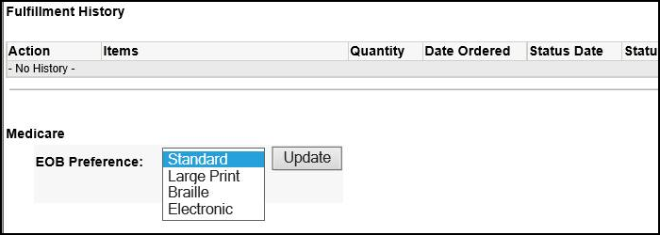  Note: If the carrier is not properly enabled with this feature in PeopleSafe, you may change the beneficiary preference via Member Profile and Communication Preferences on Caremark.com. Refer to Opt In for Electronic EOBs - Through Caremark.com and Opt-Out of Electronic EOB - Through Caremark.com
3 | If beneficiary opting into... |  |  | Then...
3 | Paperless EOBs |  |  | - Select Electronic.  - Select Update.  Note: If an email address is not on file, an error message will pop up to update the email.  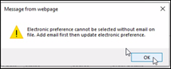  Note: When requesting an EOB under the Fulfilment Screen and selecting Medicare EOB Preference as Electronic - an update will be sent to RxClaim.
3 | Paper EOBs |  |  | - Select Standard.  - Select Update.  Note: When requesting an EOB under the Fulfilment Screen and selecting Medicare EOB Preference as Standard, Large Print or Braille - RxClaim will get updated with proper EOB preference.

Top of the Document
 Opt-In for Electronic EOBs - Through Caremark.com

The CCR should perform the steps below:

Step | Action
1 | - Do you have an account on Caremark.com?  Note: In order to opt-into paperless EOBs, the beneficiary must have an Email on file in PeopleSafe.
1 | If beneficiary says… | Then…
1 | Yes | - Great. It will only take a minute to request the change.  - We’ve already loaded up to 36 months of your EOB history to your Caremark.com account and you can begin to access them immediately.  - Once we’ve processed your paperless EOB request, you will receive an email each time a new online EOB has been added to your account.  - If at any time you wish to opt-out of paperless statements, you can change your preferences in your Caremark.com account profile.  Proceed to Step 2.
1 | No | Proceed to Quick Registration Workflow in Quick Registration for Caremark.com.
2 | You will need to log into Caremark.com.
3 | Once on Caremark.com click on Plan & Benefits from the Main Navigation Header. Then, from the drop-down menu, click on Plan Benefits Documents.  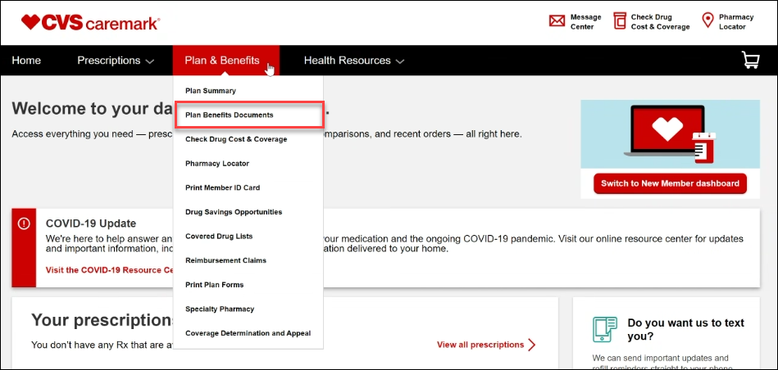
4 | - The Plan benefit documents page displays. Click Continue.  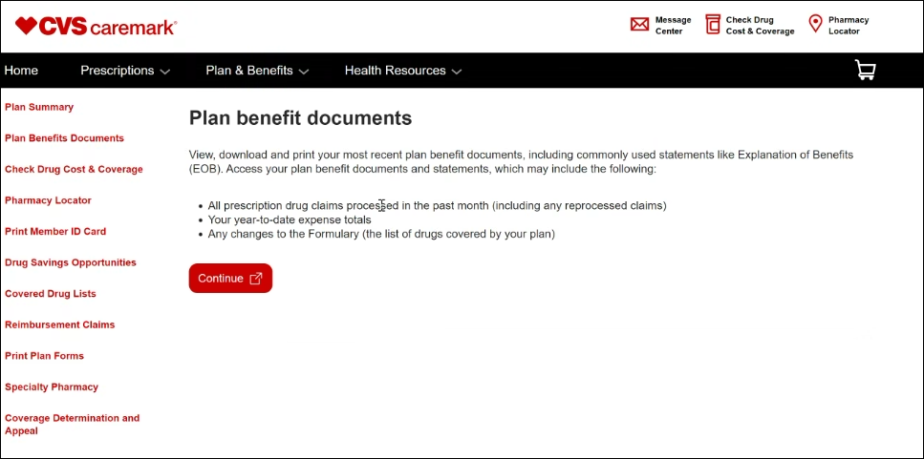
5 | We need your consent. Do you wish to continue? Select Yes.  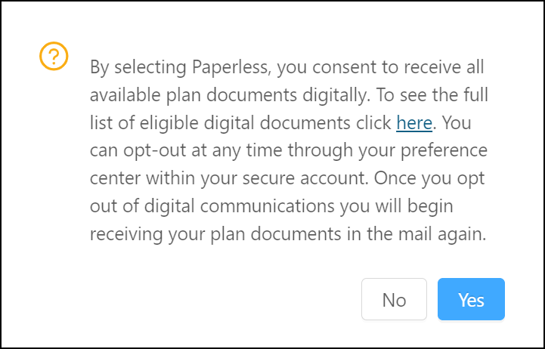
6 | Result: After completing the registration, the following displays showing EOB history with links to view and download PDF files for EOB statements for up to 36 months (3 years) of past beneficiary history.  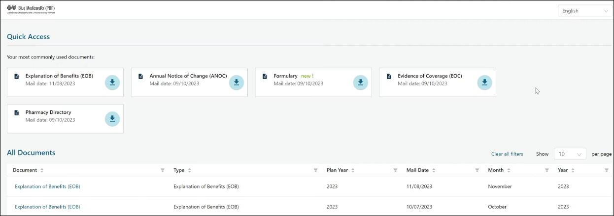  Account Features:  - Additional documents such as Annual Notice of Change (ANOC), Formulary, Evidence of Coverage (EOC), and Pharmacy Directory are available  - Manage print preferences and account settings.  - “Quick access” most recent copy of documents.  - Member can request a hard copy “Need a copy sent to you in the mail?”
7 | There are additional methods to opt-in for paperless EOBs on Caremark.com. Once on Caremark.com, click on Profile at the very top of the page.  Note: Beneficiary can also go to Update communication preferences from the Promo Important Message on the Homepage.  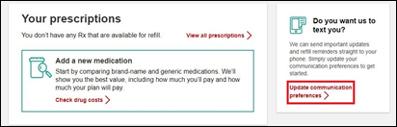  Note: Promotions and prompts may vary by beneficiary.
8 | On the Profile page, select Communication Preferences.  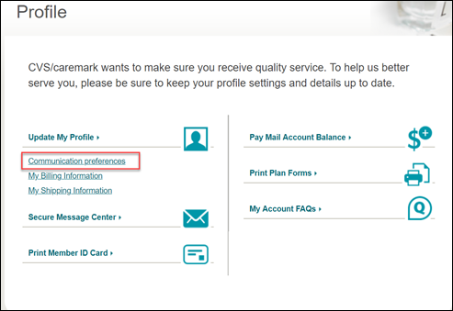
9 | On the Communication Preference page:  - Go to Paperless Setting and Click on Edit.  - Select Show all available documents.  - Select Explanation of Benefits checkbox.  - Select Save Changes.  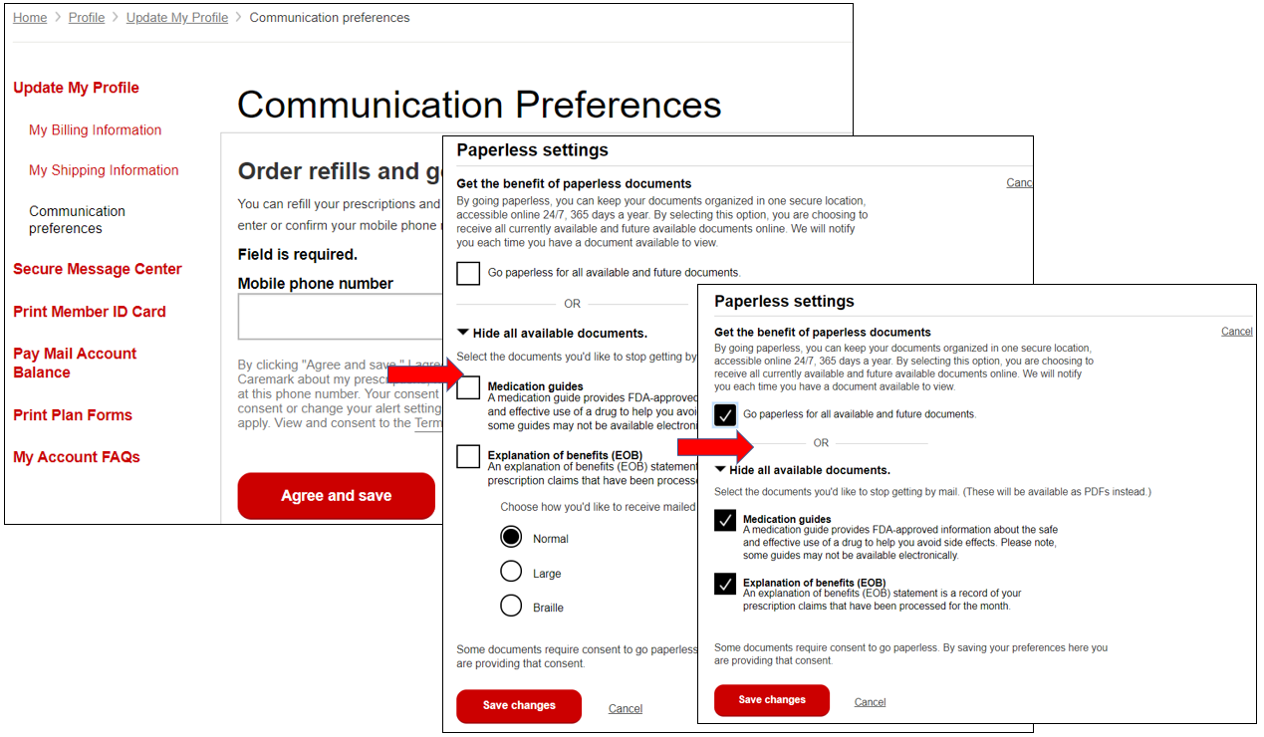

Top of the Document

Opt-Out of Electronic EOB - Through Caremark.com

The CCR should perform the steps below:

Step | Action
1 | Do you have an account on Caremark.com?
1 | If beneficiary says… | Then…
1 | Yes | Proceed to Step 2.
1 | No | Proceed to Workflow in Quick Registration for Caremark.com.
2 | Once on Caremark.com, click on Profile at the top of the page.  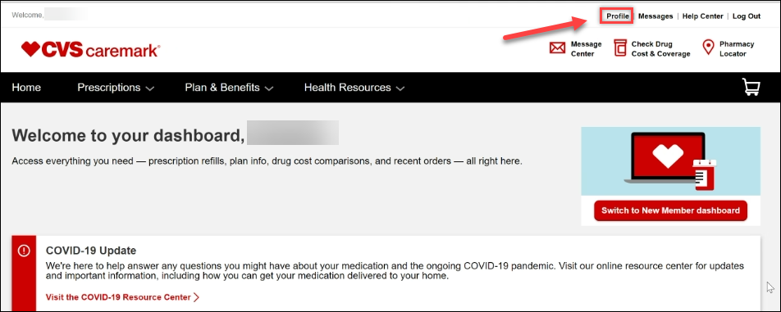
3 | Once on the Profile page, click on Communication preferences.  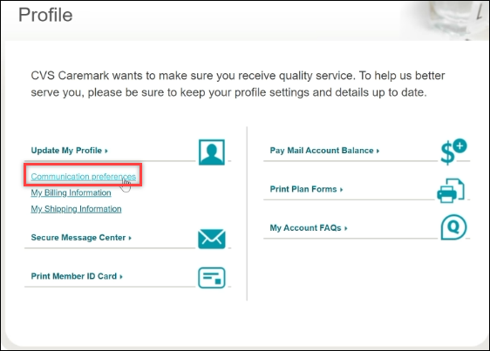
4 | - Scroll down to Paperless settings, then click Edit.  - Select Show all available documents.  - Uncheck Explanation of Benefits checkbox.  - Select Save Changes.  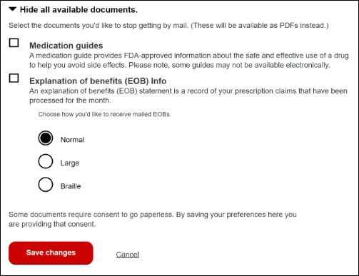  Note: The default print style is Normal however beneficiaries will be able to change to Large Print or Braille from the Print Style drop down menu as needed.

Top of the Document

Beneficiary Did Not Receive Electronic EOB Email

The CCR should perform the following:

Note: Member advises that they opted-in to Electronic EOB but did not receive the monthly email.

Step | Action
1 | Go to the Tools bar in the Main Screen of PeopleSafe.
2 | Select Find Med D EOB / TF from 6-2020 link.  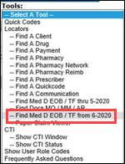  Result: System automatically authenticates and logs the CCR into ONEclick and displays list of available documents.
3 | Confirm the Email Failed text appears beside the MemberID.  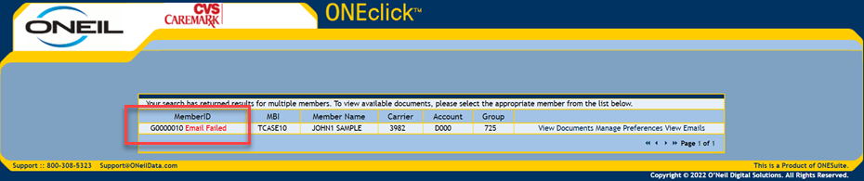  Note: If email failed, a hardcopy is automatically sent to the beneficiary.
4 | Select Manage Preferences to confirm the Email address for the beneficiary is correct under Paperless.  Result:  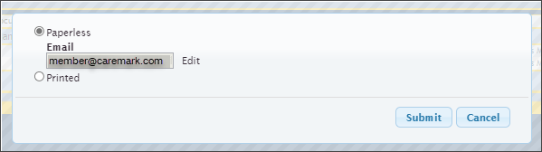  Note: Also confirm we have the correct Email on file in PeopleSafe.
4 | If the email address is... | Then...
4 | Incorrect | Click Edit and enter the correct Email address.
4 | Correct | Click Cancel.
5 | Click Submit.

Top of the Document

Beneficiary Needs Assistance Updating Electronic EOB Email or Password

The CCR should perform the following:

Note: Member advises that they opted-in to Electronic EOB and need assistance updating the email address or password.

Step | Action
1 | Go to the Tools bar in the Main Screen of PeopleSafe.
2 | Select Find Med D EOB / TF from 6-2020 link.  Result: System automatically authenticates and logs the CCR into ONEclick and displays list of available documents.
3 | Select Manage Preferences to confirm the Email address for the beneficiary under Paperless.  Note: If the beneficiary needs to reset their password, click the Reset Password link to send a reset email. This must be done after the updated email has been added to the account.  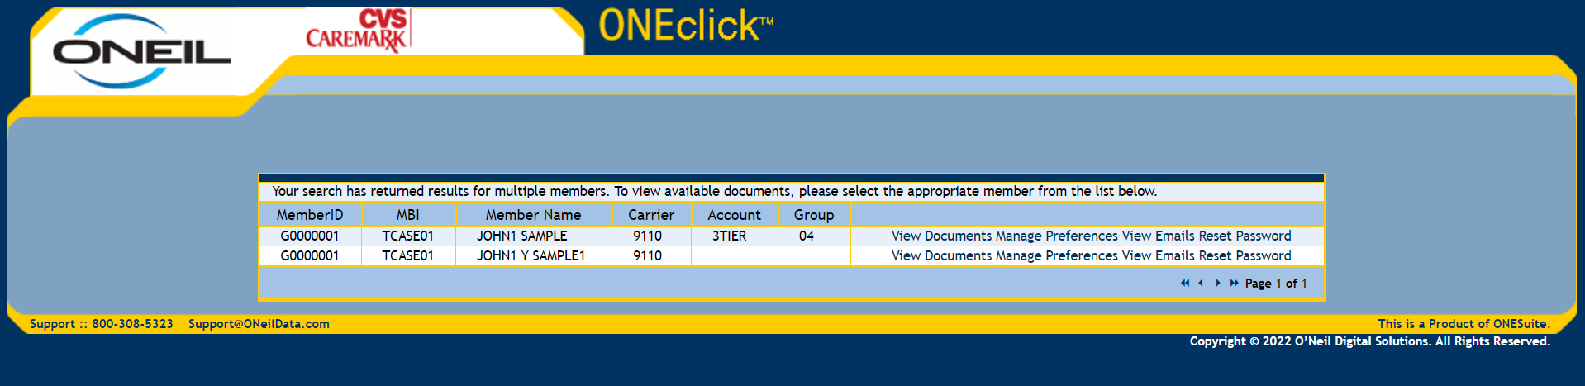
4 | Select Paperless and Click Edit to enter the correct Email address.  Note: Also confirm we have the correct Email on file in PeopleSafe.
5 | Click Submit.

Top of the Document

Paperless EOB Pop-up on Caremark.com

The CCR should perform the following if paperless EOB window pops up on Caremark.com:
Step | Action
1 | If a beneficiary logs in to Caremark.com, who is not opted in for electronic/paperless EOBs, they may be presented with a pop-up shown below, offering paperless EOB option.  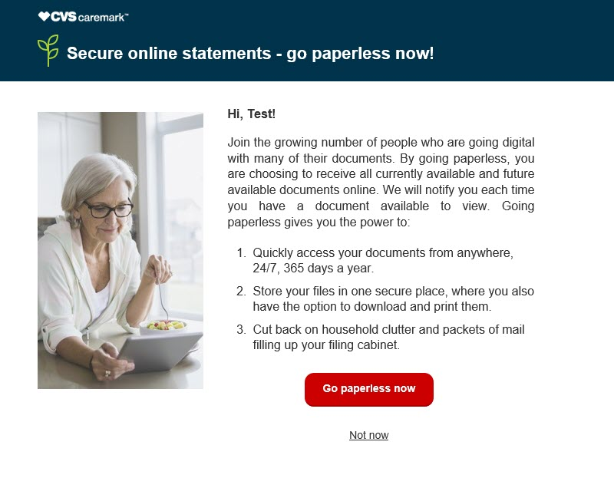
1 | If beneficiary says… | Then…
1 | Yes | - Click on Go paperless now.  - You should now be enrolled in Paperless EOBs.
1 | No | - Click on Not Now.  - The window will close, and you should now be on the Caremark.com dashboard.  Note: An optional survey opportunity regarding paperless options will display for some users. The pop-up window will no longer show to the beneficiary for 30-90 days (this setting varies.)

Top of the Document

FAQs

Use as needed:
Question | Answer
- What are the benefits of switching to paperless EOBs? | - With paperless Explanation of Benefits (EOB) statements, you can access your information online at any time, rather than waiting to receive a paper version by mail.  - We will send you an email as soon as a new EOB is ready to view.  - Paperless EOBs help you stay organized and ensure your personal health information remains secure with no shredding necessary.  - Up to 36 months of your EOBs are stored safely in a password-protected online account and organized by date so you can quickly find the statement you need.  - You can access your statements at any time, and print only those you need, which can reduce paper clutter.  - Since your statements are online, you can access them anywhere – at the pharmacy, at your doctor’s office – even when travelling.
- Can I view my EOBs online even if I am not a paperless beneficiary? | Yes - you can view, print of save up to 36 months of your EOBs online whether you are a paperless beneficiary or not.
- Can I switch back to Paper Statements? | Yes – You can switch back to receiving paper statements at any time by logging onto Caremark.com or thru calling into Care.
- How will I know my EOB is available? | If you are signed up for paperless EOBs, you will receive a monthly email notifying you your most recent EOB is available to view online.
- When will I be able to see my EOBs online once I sign up? | Monthly EOBs will typically be available by the 20th of the month that they would be mailed in.  Example: Augusts EOBs, showing July data, would be available around August 20th - beneficiary can then go on and view or print it.
- Is this functionality available for the Caremark app or mobile site? | Yes, you can also access your EOBs on the Caremark.com Mobile Site via your phone or other device, however this feature is not available in the App.
- How far back can I go to obtain EOB statements? | Many beneficiaries can see up to 36 months of EOB history across Caremark PBM plans.
- What if the eEOB functionality is not availble when I log in? | I’ll need to submit a request to research this issue. The Web Support Team will be contacting you with a resolution. Are there any benefit issues I can assist you with?  CCR Process Note: Refer to:  - Caremark.com – Web Error Form Process (Commercial and MED-D)  - Caremark.com - Web Error Form Process (Vendor Teams Only)
- Why do I have to provide my Email address? | - We will use your email address to send a notification when a new EOB is available to view online.  - If we are unable to deliver an email to the address on record, you will still be able to access your EOB online but will also receive a printed copy in the mail.
- I see a pop-up notice about electronic EOBs every time I login to my Caremark.com account. Is there any way to stop this from happening? | - The pop-up is automated and designed to make it easier to choose paperless Explanation of Benefits statements, should you decide to switch in the future.  - If you do not wish to choose paperless EOBs, simply click the Not now button, and the pop-up will disappear from the screen.
- If I opt out of electronic EOBs on the 19th of the month, do I still receive another electronic EOB on the 20th or is that opt out effective immediately and I’ll be sent a paper copy? | - If you opt out of electronic EOBs on the 19th of the month you will still receive an electronic EOB for that month.  - You will not be mailed a paper one until the next month’s mailing.  Example: You opt out on March 18th, you will receive an eEOB for March and then receive a paper copy in the mail for April.
- If it’s not immediate, how many days prior to the 20th would the I need to opt out of electronic EOBs in order to receive a paper copy in the mail for that month? | You will need to opt out by the middle of the previous month in order to begin receiving paper copies of EOB in the mail for that month.

Top of the Document

EOB Guest Preview and Paperless Opt-in

Beneficiaries can use the EOB Guest Preview when they receive an email alert. The beneficiary will need to verify his or her identify by entering their date of birth and their member ID.

Beneficiary does not need to be registered to preview their EOBs on Caremark.com.

Result: The Beneficiary EOB page and EOBs will display. The page will contain a paperless option to opt-in.
- If the beneficiary opts-in, they will be presented with further instructions to register an account and/or update communication preference, pending registration status. Confirmation text advises beneficiaries it may take up to 2 months to receive first electronic EOBs as well as capability to change preference back to paper at any time.

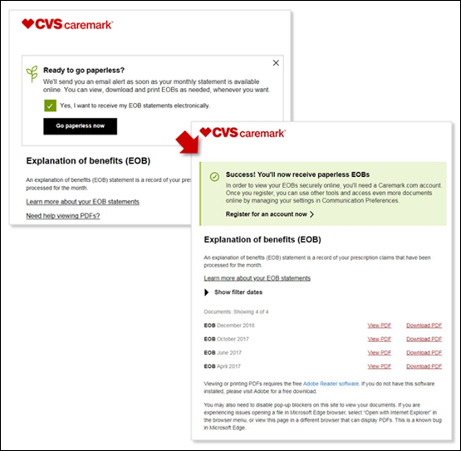

Top of the Document

EOB 1 Click Paperless Preference Setting and Opt-in

Beneficiaries may receive an email that allows them to easily opt-in to paperless EOBs by a simple click on Go paperless now. The beneficiary will be directed to the Caremark.com landing page confirming preference for EOBs has been set. It will provide further instructions to register an account and/or update communication preference, pending registration status. Beneficiary is advised it may take up to 2 months to receive first electronic EOBs as well as capability to change preference back to paper at any time.

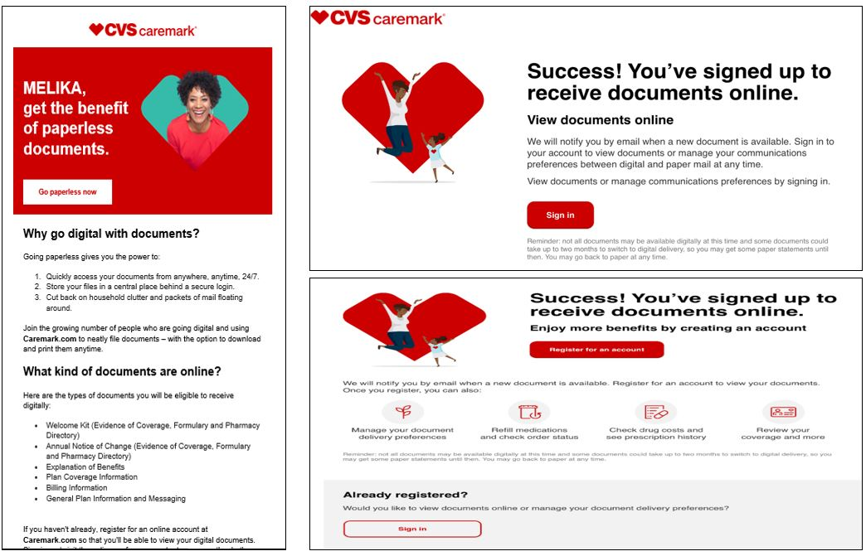

Top of the Document

Related Documents

Parent SOP: CALL-0048: Medicare Part D Customer Care Call Center Requirements-CVS Caremark Part D Services, L.L.C.
Abbreviations/Definitions: Abbreviations / Definitions

Top of the Document

Not To Be Reproduced Or Disclosed to Others Without Prior Written Approval
ELECTRONIC DATA = OFFICIAL VERSION – PAPER COPY = INFORMATIONAL ONLY

